ASSIGNMENT – 7
NAME : J. Sai Prakash
ROLL_NO : 2503A52380
Task Description #1 – Password Strength Validator

TASK 1:

Apply AI to generate at least 3 assert test cases for "is_strong_password(password)" and implement the password strength validator.

PROMPT:

Find and implement a Python function "is_strong_password(password)" that validates password strength based on the following requirements: minimum 8 characters, at least one uppercase letter, one lowercase letter, one digit, and one special character. The password must not contain spaces. Generate at least 3 assert test cases to verify the function.

CODE:

# Password Strength Validator

def is_strong_password(password):
if len(password) < 8:
return False
if " " in password:
return False
if not any(c.isupper() for c in password):
return False
if not any(c.islower() for c in password):
return False
if not any(c.isdigit() for c in password):
return False
if not any(not c.isalnum() for c in password):
return False

return True

# 3 assert test cases
assert is_strong_password("Abcd@123") == True
assert is_strong_password("abcd123") == False
assert is_strong_password("ABCD@1234") == True

print("All 3 assert test cases passed successfully!")

OUTPUT:
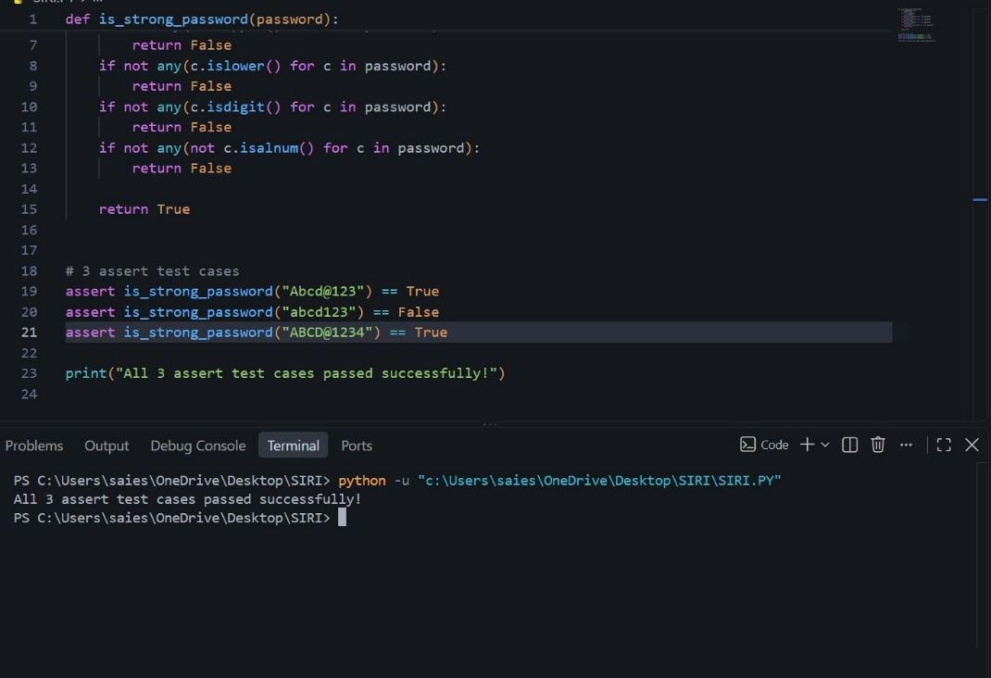

JUSTIFICATION:

- The "is_strong_password()" function checks whether the password satisfies all the required security conditions.
- "len(password) < 8" checks the minimum password length.
- "" " in password" checks whether the password contains spaces.
- "isupper()" checks for an uppercase letter.
- "islower()" checks for a lowercase letter.
- "isdigit()" checks for a number.
- "not c.isalnum()" checks for a special character.
- Three assert test cases are used to verify valid and invalid passwords.
- The first and third test cases are strong passwords, so they return "True".
- The second test case does not satisfy the requirements, so it returns "False".
- Since all three assertions pass, the password validation function works correctly.
Task Description #2 – Number Classification with Loops

TASK 2:

Use AI to generate at least 3 assert test cases for a "classify_number(n)" function. Implement the function using loops and handle edge cases.

PROMPT:

Identify and implement a Python function "classify_number(n)" that classifies a number as Positive, Negative, or Zero. The function should handle invalid inputs such as strings and "None". Use loops in the implementation and include boundary conditions such as -1, 0, and 1. Also generate at least 3 assert test cases to verify the corrected function.

CODE:

# Number Classification with Loops

def classify_number(n):
# Handle invalid inputs
if not isinstance(n, (int, float)):
return "Invalid Input"

# Use a loop to classify the number
for value in [n]:
if value > 0:
return "Positive"
elif value < 0:
return "Negative"
else:
return "Zero"

# Assert test cases
assert classify_number(10) == "Positive"
assert classify_number(-5) == "Negative"
assert classify_number(0) == "Zero"

# Boundary condition test cases
assert classify_number(1) == "Positive"
assert classify_number(-1) == "Negative"

# Invalid input test cases
assert classify_number("10") == "Invalid Input"
assert classify_number(None) == "Invalid Input"

print("All assert test cases passed successfully!")

OUTPUT:
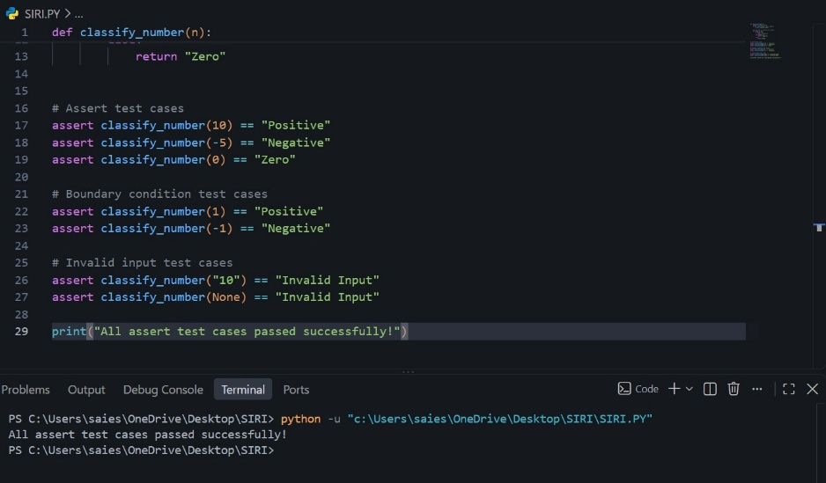

JUSTIFICATION:

- The "classify_number()" function checks whether the input is a valid number.
- If the input is a string or "None", the function returns ""Invalid Input"".
- A loop is used to process the given number and classify it.
- If the number is greater than "0", it returns ""Positive"".
- If the number is less than "0", it returns ""Negative"".
- If the number is equal to "0", it returns ""Zero"".
- The boundary values "-1", "0", and "1" are tested.
- Invalid inputs such as ""10"" and "None" are also tested.
- The assert statements confirm that the function produces the expected results.
- Since all test cases pass successfully, the number classification function works correctly.

Task Description #3 – Anagram Checker

TASK 3:

Use AI to generate at least 3 assert test cases for "is_anagram(str1, str2)" and implement the function.

PROMPT:

Identify and implement a Python function "is_anagram(str1, str2)" that checks whether two strings are anagrams. The function should ignore case, spaces, and punctuation. It should also handle edge cases such as empty strings and identical words. Generate at least 3 assert test cases to verify that the function works correctly.

CODE:

# Anagram Checker

def is_anagram(str1, str2):
# Remove spaces and punctuation and convert to lowercase
clean_str1 = ""
clean_str2 = ""

for char in str1:
if char.isalnum():
clean_str1 += char.lower()

for char in str2:
if char.isalnum():
clean_str2 += char.lower()

# Compare sorted characters
return sorted(clean_str1) == sorted(clean_str2)

# 3 assert test cases
assert is_anagram("listen", "silent") == True
assert is_anagram("hello", "world") == False
assert is_anagram("Dormitory", "Dirty Room") == True

# Edge case test cases
assert is_anagram("", "") == True
assert is_anagram("Hello", "hello") == True

print("All assert test cases passed successfully!")

OUTPUT:
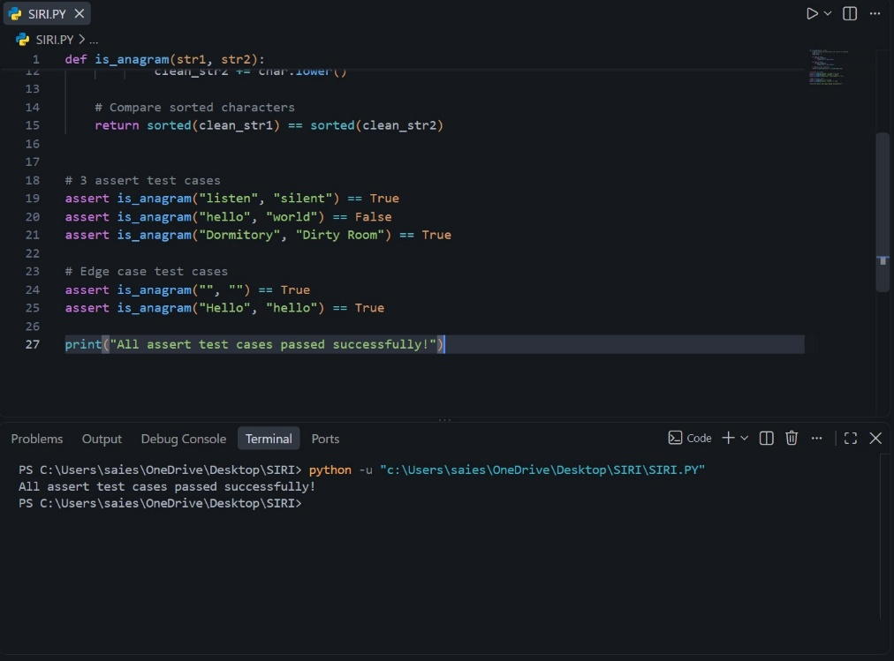

JUSTIFICATION:

- The "is_anagram()" function checks whether two strings contain the same characters.
- The "for" loops process each character in both strings.
- "isalnum()" removes spaces and punctuation by keeping only letters and numbers.
- "lower()" converts all characters to lowercase, so the comparison is case-insensitive.
- "sorted()" arranges the characters in alphabetical order before comparing them.
- Three main assert test cases check ""listen""/""silent"", ""hello""/""world"", and ""Dormitory""/""Dirty Room"".
- Additional tests check edge cases such as empty strings and identical words with different capitalization.
- Since all assertions pass, the function correctly identifies anagrams and handles the required edge cases.

Task Description #4 – Inventory Class

TASK 4:

Ask AI to generate at least 3 assert-based tests for an "Inventory" class with stock management.

Methods:

- "add_item(name, quantity)"
- "remove_item(name, quantity)"
- "get_stock(name)"

PROMPT:

Create a Python "Inventory" class for managing stock. The class should contain "add_item(name, quantity)", "remove_item(name, quantity)", and "get_stock(name)" methods. Use AI to generate at least 3 assert-based test cases to verify that items can be added, removed, and their stock can be retrieved correctly. Provide the corrected code and expected output.

CODE:

# Inventory Class with Stock Management

class Inventory:
def __init__(self):
self.stock = {}

def add_item(self, name, quantity):
if name in self.stock:
self.stock[name] += quantity
else:
self.stock[name] = quantity

def remove_item(self, name, quantity):
if name in self.stock:
self.stock[name] -= quantity

def get_stock(self, name):
return self.stock.get(name, 0)

# Create an Inventory object
inv = Inventory()

# 3 assert-based test cases
inv.add_item("Pen", 10)
assert inv.get_stock("Pen") == 10

inv.remove_item("Pen", 5)
assert inv.get_stock("Pen") == 5

inv.add_item("Book", 3)
assert inv.get_stock("Book") == 3

print("All 3 assert test cases passed successfully!")

OUTPUT:
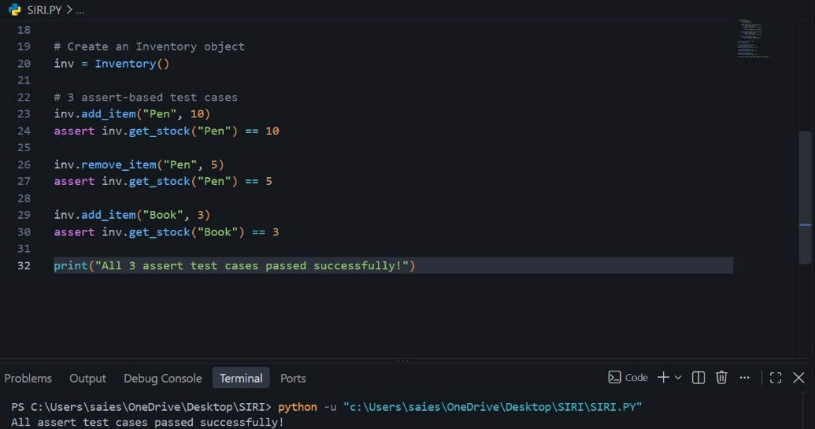

JUSTIFICATION:

- The "Inventory" class uses a dictionary to store item names and their quantities.
- The "add_item()" method adds a new item or increases the quantity of an existing item.
- The "remove_item()" method decreases the quantity of an existing item.
- The "get_stock()" method returns the current stock quantity of an item.
- Three assert-based test cases are used to verify the stock management operations.
- The first test adds 10 Pens and checks that the stock is 10.
- The second test removes 5 Pens and checks that the remaining stock is 5.
- The third test adds 3 Books and checks that the stock is 3.
- Since all assertions pass successfully, the Inventory class is functioning correctly.

Task Description #5 – Date Validation & Formatting

TASK 5:

Use AI to generate at least 3 assert test cases for "validate_and_format_date(date_str)" to check and convert dates.

PROMPT:

Create a Python function "validate_and_format_date(date_str)" that validates a date given in "MM/DD/YYYY" format. The function should handle invalid dates and return ""Invalid Date"" for invalid input. For valid dates, convert the date to "YYYY-MM-DD" format. Generate at least 3 assert test cases to verify the function, including valid and invalid dates.

CODE:

# Date Validation and Formatting

from datetime import datetime

def validate_and_format_date(date_str):
try:
# Validate the date using the required format
date = datetime.strptime(date_str, "%m/%d/%Y")

# Convert to YYYY-MM-DD format
return date.strftime("%Y-%m-%d")

except ValueError:
return "Invalid Date"

# 3 assert test cases
assert validate_and_format_date("10/15/2023") == "2023-10-15"
assert validate_and_format_date("02/30/2023") == "Invalid Date"
assert validate_and_format_date("01/01/2024") == "2024-01-01"

# Edge case test cases
assert validate_and_format_date("12/31/2023") == "2023-12-31"
assert validate_and_format_date("02/29/2024") == "2024-02-29"

print("All 3 assert test cases passed successfully!")

OUTPUT:
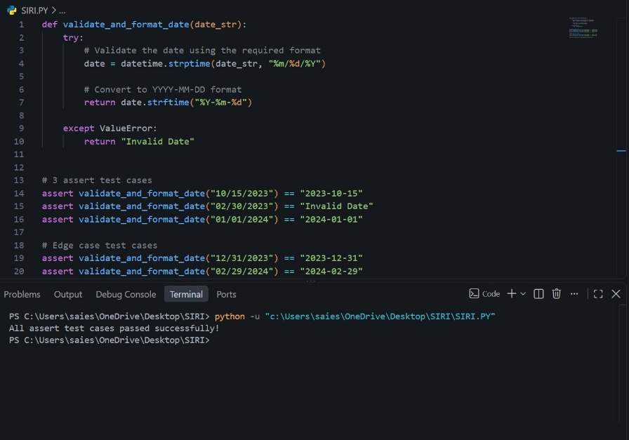

JUSTIFICATION:

- The "datetime.strptime()" function is used to validate the date according to the ""MM/DD/YYYY"" format.
- If the date is valid, "strftime()" converts it into ""YYYY-MM-DD"" format.
- If an invalid date is provided, such as ""02/30/2023"", Python raises a "ValueError".
- The "try-except" block catches the error and returns ""Invalid Date"" instead of crashing.
- Three required assert test cases are used to check valid and invalid dates.
- ""10/15/2023"" is correctly converted to ""2023-10-15"".
- ""02/30/2023"" is correctly identified as an invalid date.
- ""01/01/2024"" is correctly converted to ""2024-01-01"".
- Additional edge cases test the last day of a year and a valid leap-year date.
- Since all assertions pass successfully, the function correctly validates and formats dates.

